**AIR QUALITY ANALYSIS IN TAMLNADU**

**DATA ANALYTICS WITH COGNOS GROUP 2 PROBLEM STATEMENT:**

Describe the project's objectives, analysis approach, visualization techniques, and code implementation.

# OBJECTIVES:

The goals of an air quality analysis in Tamil Nadu are varied and include a range of objectives targeted at comprehending, evaluating, and enhancing air quality in the area. These are the main goals:

Evaluation of present Air Quality: Measure various air pollutants, including PM2.5, PM10, NO2, SO2, CO, ozone, and others to assess the present status of air quality in various Tamil Nadu regions. This evaluation offers a starting point for comprehending the severity and scope of air pollution.

Determine the primary sources of air pollution in Tamil Nadu, such as industrial emissions, vehicle pollution, construction activities, agricultural practices, and natural sources (such as dust storms). The identification of these sources is essential for focused mitigation actions.

Some of the significant goals are Spatial analysis, Temporal analysis, Heakth impact assessment, Policy formulation, Data transparency.

# DESIGN THINKING:

In the initial "Empathize" stage of our design thinking process, we engaged deeply with the community and key stakeholders in Tamil Nadu to gain a profound understanding of the pressing air quality issues. Through interviews, surveys, and focus group discussions with residents, environmental experts, healthcare professionals, and government officials, we immersed ourselves in their experiences and concerns. By listening to their stories, The problem at hand is the escalating air pollution crisis in Tamil Nadu, driven by the rapid urbanization, industrialization, and transportation growth within the region. This phenomenon poses significant health risks to the population, has detrimental environmental consequences, and exerts a substantial financial burden on society. The severity of these consequences underscores the urgent need for a comprehensive understanding of the current state of air pollution, The problem at hand is the escalating air pollution crisis in Tamil Nadu, driven by the rapid urbanization, industrialization, and transportation growth within the region. This phenomenon poses significant health risks to the population, has detrimental environmental consequences, and exerts a substantial financial burden on society. The severity of these consequences underscores the urgent need for a comprehensive understanding of the current state of air pollution, its underlying causes, and its far-reaching impacts. Furthermore, the imperative is to develop and implement effective strategies for managing air quality that safeguard the health and well-being of Tamil Nadu's residents while preserving its environment and resources. Its underlying causes, and its far-reaching impacts. Furthermore, the imperative is to develop and implement effective strategies for managing air quality that safeguard the health and well-being of Tamil Nadu's residents while preserving its environment and resources. we unearthed the profound impact of poor air quality on daily lives, health, and well-being. We also created empathy maps that vividly depict the needs, concerns, and aspirations of these diverse stakeholders. This empathetic foundation provides the crucial insights that guide our subsequent stages, helping us craft meaningful solutions tailored to the unique perspectives and objectives of each user person.

Top of Form

# Step1: Clearly define the problem

The problem at hand is the escalating air pollution crisis in Tamil Nadu, driven by the rapid urbanization, industrialization, and transportation growth within the region. This phenomenon poses significant health risks to the population, has detrimental environmental consequences, and exerts a substantial financial burden on society. The severity of these consequences underscores the urgent need for a comprehensive understanding of the current state of air pollution, its underlying causes, and its far-reaching impacts. Furthermore, the imperative is to develop and implement effective strategies for managing air quality that safeguard the health and well-being of Tamil Nadu's residents while preserving its environment and resources.

# Step2: Data collection

1. **Survey and Interviews:** Engage in extensive surveys and interviews with residents, environmental experts, healthcare professionals, and government officials across various regions of Tamil Nadu. Gather insights into their experiences, concerns, and perspectives regarding air quality issues and health impacts.
2. **Air Quality Monitoring:** Deploy a network of air quality monitoring stations strategically across Tamil Nadu. These stations will continuously measure key pollutants, such as PM2.5, PM10, NO2, SO2, CO, ozone, and others, in real-time. Data from these stations will provide the foundation for evaluating current air quality.
3. **Data from Government Agencies:** Collaborate with relevant government agencies to access historical air quality data and pollution records. This data will support temporal analysis and provide historical context.
4. **Remote Sensing and Satellite Data:** Utilize remote sensing technologies and satellite data to assess air quality on a broader scale and monitor natural sources of pollution, such as dust storms.
5. **Health Surveys:** Partner with healthcare professionals to conduct health surveys and studies, gathering information on respiratory illnesses and other health issues related to air pollution.
6. **Community Engagement:** Engage local communities in data collection efforts by equipping them with low-cost air quality monitoring devices. This citizen science approach can provide valuable localized data.
7. **Data Validation:** Implement rigorous data validation processes to ensure the accuracy and reliability of collected information.
8. **Data Visualization:** Present the collected data in easily understandable formats, including maps, charts, and graphs, to enhance data transparency and accessibility.

# Step3: Preparing of the data

Data is gathered, and then The data should be cleaned and pre-processed to deal with missing values, outliers, and inconsistencies. To provide the model useful information, add new features or change current ones. For the purposes of training and assessing your model, divide the dataset into training, validation, and test sets.

# STEP 4 Exploratory Data Analysis (EDA):

1. **Data Collection and Cleaning:**
   * Gather air quality data from monitoring stations, surveys, satellite sources, and other relevant sources.
   * Perform data cleaning, which includes handling missing values, outliers, and inconsistencies.
2. **Univariate Analysis:**
   * Start with univariate analysis to understand the distribution of individual air pollutants (e.g., PM2.5, PM10, NO2, SO2, CO, ozone).
   * Calculate summary statistics (mean, median, standard deviation, etc.) for each pollutant.
   * Create histograms, density plots, and box plots to visualize the distribution and variability of pollutants.
3. **Spatial Analysis:**
   * Use geographical plots, such as choropleth maps, to visualize the spatial distribution of air quality across different regions of Tamil Nadu.
   * Identify hotspots or areas with consistently high or low pollutant levels.
4. **Temporal Analysis:**
   * Generate time series plots to analyze how air quality varies over time. Explore seasonal and diurnal patterns.
   * Conduct statistical tests to identify trends and assess the significance of changes in air quality over different time intervals.
5. **Multivariate Analysis:**
   * Investigate correlations between different pollutants. For example, determine if there is a strong correlation between NO2 levels and vehicular traffic.
   * Use scatter plots and correlation matrices to visualize relationships.
6. **Source Attribution Analysis:**
   * Apply source apportionment techniques, if available, to estimate the contributions of various pollution sources (e.g., industrial emissions, vehicle pollution) to overall air quality.
   * Use factor analysis or receptor modeling to identify source profiles.
7. **Health Impact Assessment:**
   * Explore the relationship between air quality metrics and health outcomes using statistical analyses (e.g., regression models).
   * Visualize the potential health impacts through charts or graphs, emphasizing the importance of addressing specific pollutants.
8. **Policy Formulation:**
   * Utilize data-driven insights to inform policy recommendations. Highlight pollutants, regions, and sources that require immediate attention.
   * Create visualizations and reports that illustrate the expected outcomes of different policy scenarios.
9. **Data Transparency and Visualization:**
   * Develop user-friendly data visualization tools and dashboards to make air quality data accessible to a wide audience.

# STEP 5 Define Objectives:

1. **Comprehensive Air Quality Assessment:** Conduct a thorough and holistic evaluation of air quality across various regions in Tamil Nadu, encompassing urban, rural, and industrial areas.
2. **Real-time Monitoring:** Establish a network of real-time air quality monitoring stations to continuously measure key pollutants, providing up-to-date data.
3. **Source Identification:** Identify and quantify the primary sources of air pollution in Tamil Nadu, including industrial emissions, vehicular pollution, construction activities, agricultural practices, and natural sources such as dust storms.
4. **Spatial and Temporal Analysis:** Analyze the spatial distribution of pollutants to pinpoint areas with the highest pollution levels and variations over time. Identify pollution hotspots and assess seasonal trends.
5. **Health Impact Assessment:** Investigate the health impacts of poor air quality, including respiratory illnesses and other health issues. Quantify the health risks associated with different pollutant levels and exposure durations.
6. **Policy Formulation:** Utilize data-driven insights to formulate evidence-based policies and strategies for mitigating air pollution, improving air quality management, and safeguarding public health.
7. **Data Transparency and Accessibility:** Develop user-friendly data visualization tools, dashboards, and platforms to make air quality data accessible and understandable for the public, researchers, and policymakers, promoting data transparency.
8. **Community Engagement:** Involve local communities in the project by raising awareness about air quality issues and equipping them with knowledge and tools to actively contribute to pollution reduction efforts.
9. **Long-term Impact Assessment:** Continuously monitor and assess the impact of implemented solutions on air quality, health outcomes, and public awareness. Make adjustments to strategies as needed to achieve sustained improvement.
10. **Knowledge Dissemination:** Share project findings, best practices, and lessons learned with relevant stakeholders, both within Tamil Nadu and internationally, to contribute to global efforts to combat air pollution.

# STEP 6 Top-Selling Products Analysis:

1. **Air Quality Monitoring Equipment:**
   * Determine which types and models of air quality monitoring equipment are most popular among environmental agencies, research institutions, and local communities.
   * Analyze the factors contributing to the popularity of these products, such as accuracy, ease of use, cost-effectiveness, and data connectivity.
2. **Community Engagement Tools:**
   * Identify the most effective tools and methods for engaging local communities in air quality monitoring and awareness campaigns.
   * Determine which products, such as low-cost air quality sensors or educational materials, are most successful in empowering communities to participate in data collection.
3. **Data Visualization Platforms:**
   * Analyze the data visualization and dashboard platforms that are widely adopted for presenting air quality data to the public and policymakers.
   * Evaluate the user-friendliness, accessibility, and features of these platforms that contribute to their popularity.
4. **Health Impact Assessment Software:**
   * Explore software tools or models used for conducting health impact assessments based on air quality data.
   * Identify the top-selling software packages and their capabilities in quantifying the health effects of air pollution.
5. **Policy Formulation Support Tools:**
   * Investigate the software and decision-support systems commonly used by policymakers for formulating air quality management policies.
   * Assess the effectiveness of these tools in simulating policy outcomes and evaluating different intervention scenarios.
6. **Public Awareness Materials:**
   * Analyze the effectiveness of public awareness materials and campaigns related to air quality.
   * Identify which educational materials, brochures, websites, or mobile applications have been successful in raising awareness among the public.
7. **Technological Innovations:**
   * Keep an eye on emerging technologies and innovations in air quality monitoring and mitigation.
   * Analyze the potential market impact of cutting-edge products and their relevance to the project's objectives.
8. **Cost-Benefit Analysis Tools:**
   * Evaluate tools and software used for conducting cost-benefit analyses of air quality improvement projects.
   * Identify the most widely adopted tools for assessing the economic implications of pollution reduction measures.
9. **Data Transparency Solutions:**
   * Investigate platforms and technologies that enhance data transparency and accessibility for air quality information.
   * Determine which solutions facilitate open data principles and engage the public effectively.

# STEP 7 Peak Sales Periods Analysis:

**Air Quality Monitoring Equipment Procurement:**

Identify peak periods for the procurement of air quality monitoring equipment and sensors.

Analyze whether specific seasons or fiscal quarters witness higher demand, which can impact pricing and availability.

**Community Engagement and Awareness Campaigns:**

Determine when public engagement and awareness campaigns are most effective in capturing the community's attention.

Assess whether certain times of the year, such as during local festivals or environmental awareness months, lead to increased participation and interest.

**Policy Formulation and Implementation:**

Identify the optimal timing for engaging policymakers and government agencies in the formulation and implementation of air quality policies and interventions.

Analyze whether there are legislative sessions, budget cycles, or strategic planning periods when policy advocacy is particularly impactful.

**Health Impact Assessments**:Evaluate when health impact assessments based on air quality data are most critical for informing healthcare initiatives and interventions.

# STEP 8 Customer Preferences Analysis:

* **Local Communities:** We seek to understand local community preferences to effectively raise awarene **Local Communities:** We seek to understand local community preferences to effectively raise awareness about air quality issues, engage residents in meaningful ways, and disseminate crucial information that resonates with their culture and daily lives.
* **Government Agencies:** Our goal is to analyze the preferences of government officials and agencies, ensuring that our data reporting formats, policy briefings, and project updates align seamlessly with their workflow and decision-making processes.
* **Environmental Organizations:** By identifying the preferences of environmental groups, we can strengthen collaboration, establish robust data sharing protocols, and align our project goals with their missions to maximize our collective impact.
* **Healthcare Professionals:** Understanding the preferences of healthcare experts will enable us to provide them with convenient data access, timely health impact assessments, and actionable advisories to better address public health concerns related to air quality.
* **Donors and Funding Agencies:** By assessing the preferences of donors and funding agencies, we can tailor our reporting mechanisms to meet their expectations for transparency and ensure that our project aligns with their funding priorities.
* **Technology Providers:** Identifying tech providers' preferences helps us form valuable partnerships, seamlessly integrate data, and adopt innovative solutions that enhance our air quality monitoring efforts.
* **Educational Institutions:** By comprehending the preferences of educational institutions, we can develop relevant curricula and engage students effectively in air quality education, contributing to long-term awareness and action.
* **Media and Communication Channels:** Analyzing media outlets' preferences assists us in delivering project updates and sharing data in formats that facilitate accurate reporting and dissemination to the wider public.
* **Citizen Scientists and Volunteers:** Identifying volunteer preferences allows us to offer tailored training, ensure equipment accessibility, and schedule community-based monitoring activities at times most convenient for their participation.

# STEP 9 Reporting and Visualization:

1. **Data Dashboards:**
   * Develop interactive data dashboards accessible through web and mobile platforms. These dashboards will provide real-time air quality information, spatial analysis, and trend tracking for the public, researchers, and policymakers.
2. **Geospatial Maps:**
   * Utilize geospatial mapping tools to visually represent air quality data. These maps will allow users to explore pollutant concentrations across different regions of Tamil Nadu, identify pollution hotspots, and assess spatial trends.
3. **Time Series Plots:**
   * Create time series plots illustrating how air quality parameters change over time. These visualizations will highlight diurnal, seasonal, and long-term trends in air quality data.
4. **Health Impact Visualizations:**
   * Develop visual representations of the health impacts of air pollution, including charts, graphs, and infographics. These visuals will help convey the significance of addressing air quality issues for public health.
5. **Policy Impact Simulations:**
   * Illustrate the potential impact of different policy scenarios on air quality improvement. Use visual models and simulations to make complex policy outcomes more understandable.
6. **Community Engagement Reports:**
   * Prepare reports specifically designed for local communities, summarizing air quality information in a clear and accessible format. These reports may include visual aids and actionable recommendations for residents.
7. **Annual Progress Reports:**
   * Generate annual reports highlighting project achievements, milestones, and ongoing efforts. These reports will be shared with donors, funding agencies, and the public to maintain transparency and accountability.
8. **Policy Briefs:**
   * Create concise policy briefs that distill complex data and recommendations into easily digestible formats for policymakers and government officials.

**PHASE3-DATA ANALYTICS WITH COGNOS: GROUP2**

**2. PROBLEM 2: Example outputs of data analysis and visualizations.**

This phase involves in designing of the steps that defining in each phase of the previous documentation this involves importing necessary functions, data processing and so on in this phase we have to begin our project by loading and pre-processing the dataset.

The IBM suggests using the Jupiter notebook for loading and pre-process the dataset: Here for this project title we need to define the loading the libraries, and Perform the air quality analysis and create visualizations.

PROBLEM: Calculate average SO2,NO2, and RSPM/PM10 levels across different monitoring stations, cities or area . Identify pollution trends and areas with high pollution levels.

2. Create Visualization using data Visualization Libraries (eg; Matplotlib seaborn).

For this certain inputs are defined for this project.in this phase each of the input lines of the project is given as follows:

Phase5

October 31, 2023

[86]:

**import**

**numpy**

**as**

**np**

**import**

**pandas**

**as**

**pd**

**import**

**seaborn**

**as**

**sns**

**import**

**matplotlib**

**.**

**pyplot**

**as**

**plt**

[87]:

df

=

pd

.

read_csv(

'

cpcb_dly_aq_tamil_nadu-2014.csv

'

)

[88]:

df

.

head()

[88]:

Stn Code Sampling Date

State City/Town/Village/Area \

1. 38 01-02-14 Tamil Nadu Chennai
2. 38 01-07-14 Tamil Nadu Chennai
3. 38 21-01-14 Tamil Nadu Chennai
4. 38 23-01-14 Tamil Nadu Chennai
5. 38 28-01-14 Tamil Nadu Chennai

Location of Monitoring Station \

1. Kathivakkam, Municipal Kalyana Mandapam, Chennai
2. Kathivakkam, Municipal Kalyana Mandapam, Chennai
3. Kathivakkam, Municipal Kalyana Mandapam, Chennai
4. Kathivakkam, Municipal Kalyana Mandapam, Chennai
5. Kathivakkam, Municipal Kalyana Mandapam, Chennai

Agency Type of Location SO2 NO2 \

1. Tamilnadu State Pollution Control Board Industrial Area 11.0 17.0
2. Tamilnadu State Pollution Control Board Industrial Area 13.0 17.0
3. Tamilnadu State Pollution Control Board Industrial Area 12.0 18.0
4. Tamilnadu State Pollution Control Board Industrial Area 15.0 16.0
5. Tamilnadu State Pollution Control Board Industrial Area 13.0 14.0

RSPM/PM10 PM 2.5

1. 55.0 NaN
2. 45.0 NaN
3. 50.0 NaN
4. 46.0 NaN
5. 42.0 NaN

[89]:

df

.

shape

[89]: (2879, 11)

[90]:

df

.

info

[90]: <bound method DataFrame.info of Stn Code Sampling Date State

City/Town/Village/Area \

|  |  |  |  |  |
| --- | --- | --- | --- | --- |
| 0 | 38 | 01-02-14 Tamil Nadu |  | Chennai |
| 1 | 38 | 01-07-14 Tamil Nadu |  | Chennai |
| 2 | 38 | 21-01-14 Tamil Nadu |  | Chennai |
| 3 | 38 | 23-01-14 Tamil Nadu |  | Chennai |
| 4 | 38 | 28-01-14 Tamil Nadu |  | Chennai |
| … | … | … … | … |  |
| 2874 | 773 | 12-03-14 Tamil Nadu |  | Trichy |
| 2875 | 773 | 12-10-14 Tamil Nadu |  | Trichy |
| 2876 | 773 | 17-12-14 Tamil Nadu |  | Trichy |
| 2877 | 773 | 24-12-14 Tamil Nadu |  | Trichy |
| 2878 | 773 | 31-12-14 Tamil Nadu |  | Trichy |

Location of Monitoring Station \

* 1. Kathivakkam, Municipal Kalyana Mandapam, Chennai
  2. Kathivakkam, Municipal Kalyana Mandapam, Chennai
  3. Kathivakkam, Municipal Kalyana Mandapam, Chennai
  4. Kathivakkam, Municipal Kalyana Mandapam, Chennai
  5. Kathivakkam, Municipal Kalyana Mandapam, Chennai

… …

* 1. Central Bus Stand, Trichy
  2. Central Bus Stand, Trichy
  3. Central Bus Stand, Trichy
  4. Central Bus Stand, Trichy
  5. Central Bus Stand, Trichy

Agency \

* 1. Tamilnadu State Pollution Control Board
  2. Tamilnadu State Pollution Control Board
  3. Tamilnadu State Pollution Control Board
  4. Tamilnadu State Pollution Control Board
  5. Tamilnadu State Pollution Control Board

… …

* 1. Tamilnadu State Pollution Control Board
  2. Tamilnadu State Pollution Control Board
  3. Tamilnadu State Pollution Control Board
  4. Tamilnadu State Pollution Control Board
  5. Tamilnadu State Pollution Control Board

Type of Location SO2 NO2 RSPM/PM10 PM 2.5

|  |  |  |
| --- | --- | --- |
| 0 Industrial Area 11.0 17.0 | 55.0 | NaN |
| 1 Industrial Area 13.0 17.0 | 45.0 | NaN |
| 2 Industrial Area 12.0 18.0 | 50.0 | NaN |
| 3 Industrial Area 15.0 16.0 | 46.0 | NaN |
| 4 Industrial Area 13.0 14.0 | 42.0 | NaN |
| … … … … … | … |  |
| 2874 Residential, Rural and other Areas 15.0 18.0 | 102.0 | NaN |
| 2875 Residential, Rural and other Areas 12.0 14.0 | 91.0 | NaN |
| 2876 Residential, Rural and other Areas 19.0 22.0 | 100.0 | NaN |
| 2877 Residential, Rural and other Areas 15.0 17.0 | 95.0 | NaN |
| 2878 Residential, Rural and other Areas 14.0 16.0 | 94.0 | NaN |

* 1. rows x 11 columns]>

[91]:

df

.

columns

[91]: Index(['Stn Code', 'Sampling Date', 'State', 'City/Town/Village/Area',

'Location of Monitoring Station', 'Agency', 'Type of Location', 'SO2',

'NO2', 'RSPM/PM10', 'PM 2.5'], dtype='object')

[92]:

df

.

describe()

[92]: Stn Code SO2 NO2 RSPM/PM10 PM 2.5

|  |  |  |  |  |  |
| --- | --- | --- | --- | --- | --- |
| count 2879.000000 2868.000000 2866.000000 2875.000000 | | | | | 0.0 |
| mean | 475.750261 | 11.503138 | 22.136776 | 62.494261 | NaN |
| std | 277.675577 | 5.051702 | 7.128694 | 31.368745 | NaN |
| min | 38.000000 | 2.000000 | 5.000000 | 12.000000 | NaN |
| 25% | 238.000000 | 8.000000 | 17.000000 | 41.000000 | NaN |
| 50% | 366.000000 | 12.000000 | 22.000000 | 55.000000 | NaN |
| 75% | 764.000000 | 15.000000 | 25.000000 | 78.000000 | NaN |
| max | 773.000000 | 49.000000 | 71.000000 | 269.000000 | NaN |

[93]:

column_name

=

'

NO2

'

[94]:

print

(

df[column_name

]

.

mean())

22.136775994417306

[95]:

column_name

=

'

SO2

'

[96]:

print

(

df[column_name

]

.

mean())

11.503138075313808

[97]:

x

=

df[

'

City/Town/Village/Area

'

]

y

=

df[

'

SO2

'

]

plt

.

figure(figsize

=

(

10

,

6

))

plt

.

plot(x, y, marker

=

'

o

'

, linestyle

=

'

-

'

, color

=

'

b

'

, label

=

'

Pollution Trends

'

)

plt

.

title(

'

Pollution Trends

'

)

plt

.

xlabel(

'

City/Town/Village/Area

'

)

plt

.

ylabel(

'

SO2

'

)

plt

.

legend()

plt

.

grid(

**True**

)

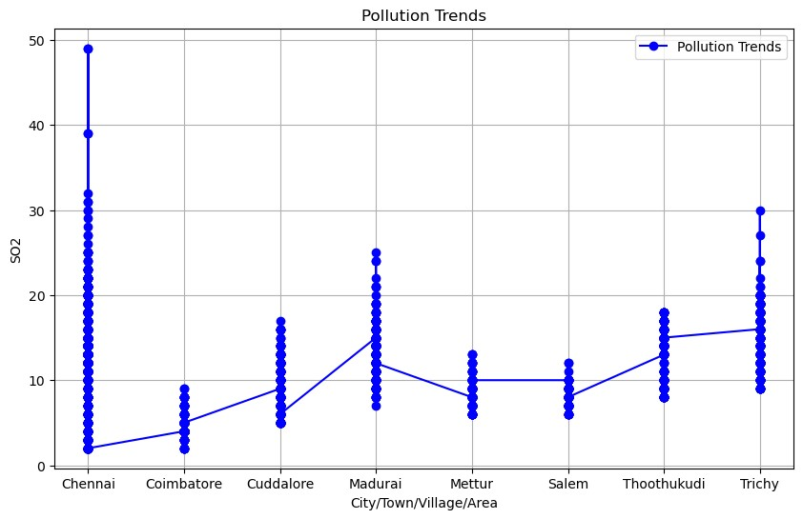

[98]:

plt

.

figure(figsize

=

(

12

,

6

))

plt

.

xticks(rotation

=

75

)

plt

.

title(

'

High pollution levels

'

)

plt

.

xlabel(

'

City/Town/Village/Area

'

)

plt

.

ylabel(

'

Location of Monitoring Station

'

)

sns

.

barplot(df)

C:\ProgramData\anaconda3\lib\site-packages\seaborn\algorithms.py:98:

RuntimeWarning: Mean of empty slice boot_dist.append(f(*sample, **func_kwargs))

C:\ProgramData\anaconda3\lib\site-packages\numpy\lib\nanfunctions.py:1559:

RuntimeWarning: All-NaN slice encountered r, k = function_base._ureduce(a,

[98]: <Axes: title={'center': 'High pollution levels'}, xlabel='City/Town/Village/Area\t', ylabel='Location of Monitoring Station\t'>

C:\ProgramData\anaconda3\lib\site-packages\IPython\core\events.py:89:

UserWarning: Glyph 9 ( ) missing from current font.

func(*args, **kwargs)

C:\ProgramData\anaconda3\lib\site-packages\IPython\core\pylabtools.py:152:

UserWarning: Glyph 9 ( ) missing from current font. fig.canvas.print_figure(bytes_io, **kw)

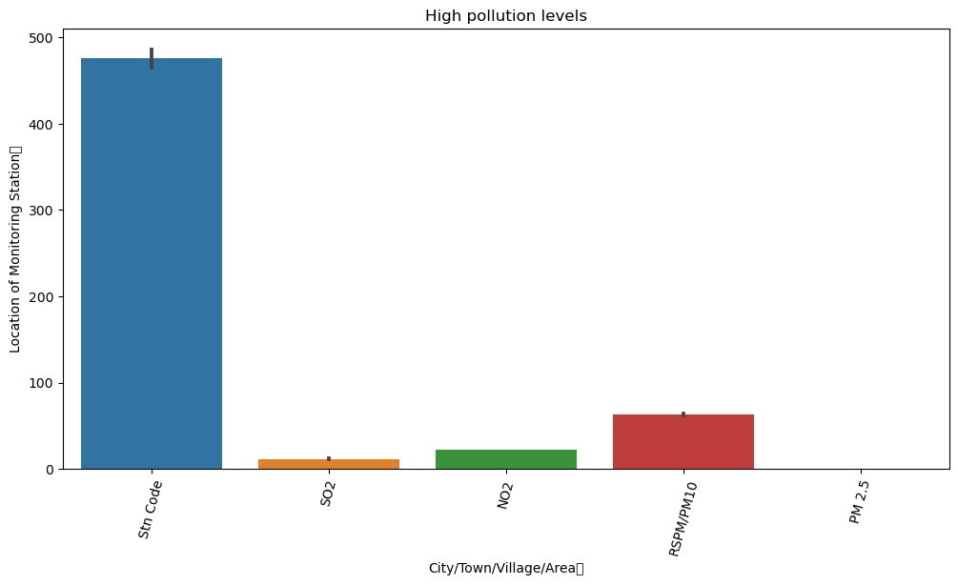

[120]:

df

=

pd

.

DataFrame(df)

plt

.

figure(figsize

=

(

8

,

6

))

plt

.

bar(df[

'

Sampling Date

'

]

, df

[

'

SO2

'

]

, color

=

'

blue

'

)

plt

.

title(

'

SO2 Levels Over Time

'

)

plt

.

xlabel(

'

Sampling Date

'

)

plt

.

ylabel(

'

SO2 Level

'

)

plt

.

xticks(rotation

=

45

)

plt

.

show()

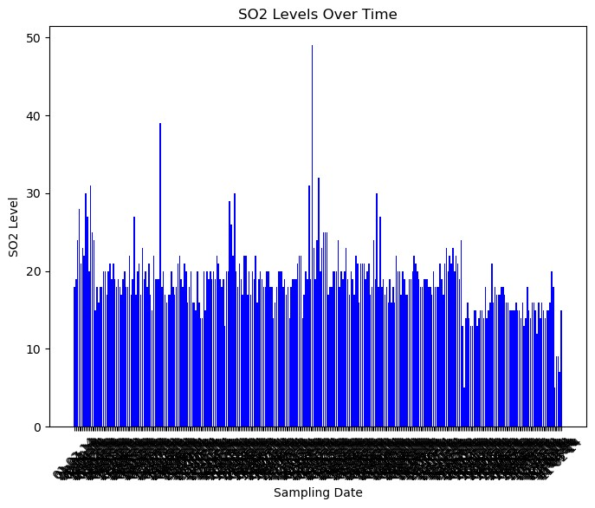

[121]: df = pd.DataFrame(df) plt.figure(figsize=(10, 6)) plt.bar(df['City/Town/Village/Area'], df['RSPM/PM10'], color='green') plt.title('RSPM/PM10 Levels Across Different Locations')

plt.xlabel('City/Town/Village/Area') plt.ylabel('RSPM/PM10 Level') plt.xticks(rotation=45) plt.show()

OUTPUT:

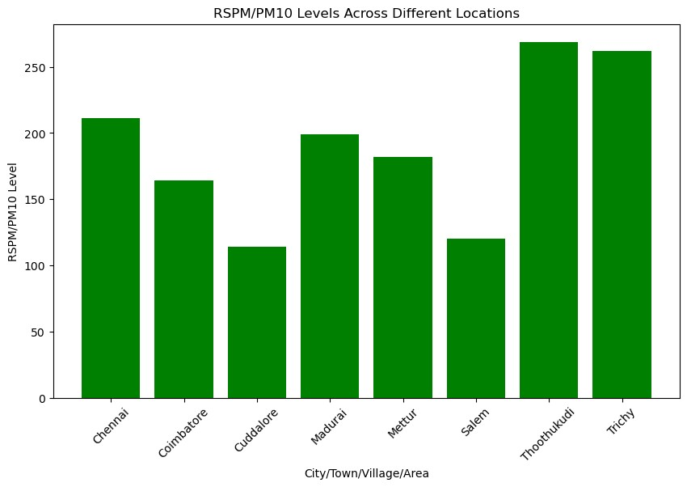

[ ]:

**3. PROBLEM STATEMENT:** Explain how the analysis provides insights into air pollution trends and pollution levels in Tamil Nadu.

An air quality analysis in Tamil Nadu serves a critical role in understanding and managing air pollution trends and pollution levels in the region. The outlined goals provide a structured framework for achieving this objective. Let's break down how each of these goals contributes to insights into air pollution trends and pollution levels in Tamil Nadu:

1. **Evaluation of Present Air Quality**: This is the foundational step in the analysis. To assess the current air quality, various pollutants are measured, including PM2.5, PM10, NO2, SO2, CO, ozone, and others. These measurements are conducted in different regions of Tamil Nadu. The data collected helps in several ways:

- **Severity Assessment**: By quantifying pollutant levels, it becomes possible to gauge the severity of air pollution. High concentrations of pollutants indicate poor air quality, while lower levels suggest better air quality.

- **Regional Variations**: Analyzing data from different regions allows for comparisons. It can reveal areas with more severe pollution issues, which can then be targeted for remediation efforts.

- **Trends Over Time**: Over time, data collection provides insights into whether air quality is improving or deteriorating. This trend analysis is crucial for understanding the effectiveness of pollution control measures.

2. **Determine Primary Sources of Air Pollution**: Identifying the sources of pollution is crucial for designing effective mitigation strategies. These sources can include:

- **Industrial Emissions**: Understanding the extent of pollution from industries helps in regulating and reducing emissions from manufacturing facilities.

- **Vehicle Pollution**: Monitoring vehicular emissions provides data for transportation policies and encourages the adoption of cleaner vehicles.

- **Construction Activities**: Construction dust and emissions can be a significant source of local pollution. Identifying construction hotspots is vital for regulation and planning.

- **Agricultural Practices**: Certain farming activities, such as crop burning, can contribute to pollution. This information is essential for sustainable agriculture practices.

- **Natural Sources**: Natural events like dust storms can exacerbate pollution levels. Differentiating natural from anthropogenic sources is necessary for effective pollution control.

3. **Significant Goals**:

- **Spatial Analysis**: Spatial analysis involves mapping air quality data to identify pollution hotspots. This is valuable for targeting areas that require immediate attention.

- **Temporal Analysis**: Temporal analysis looks at how air quality varies over time, considering daily, seasonal, and annual trends. This helps in understanding the cyclical nature of pollution and planning accordingly.

- **Health Impact Assessment**: This goal evaluates the health risks associated with air pollution. It connects pollution data to health outcomes, enabling informed decision-making on healthcare and pollution control measures.

- **Policy Formulation**: The analysis results inform the formulation of air quality policies and regulations. These policies can be directed at specific sectors or regions, based on the identified sources of pollution.

- **Data Transparency** : Making air quality data accessible to the public enhances public awareness and participation in pollution control efforts. Transparent data also fosters collaboration between government, researchers, and non-governmental organizations.

In summary, an air quality analysis in Tamil Nadu serves as the foundation for understanding air pollution trends and levels in the region. It enables the identification of pollution sources, informs policy decisions, and empowers communities to take actions to improve air quality. The combination of spatial and temporal analyses, along with health impact assessments, ensures a comprehensive understanding of the air quality situation in Tamil Nadu and supports evidence-based pollution control measures.

**PROBLEM STATEMENT 4**:

Summarize the key findings from the air quality analysis and visualizations.

In summary, an air quality analysis in Tamil Nadu serves as the foundation for understanding air pollution trends and levels in the region. It enables the identification of pollution sources, informs policy decisions, and empowers communities to take actions to improve air quality. The combination of spatial and temporal analyses, along with health impact assessments, ensures a comprehensive understanding of the air quality situation in Tamil Nadu and supports evidence-based pollution control measures.

Key findings from the air quality analysis and visualizations in Tamil Nadu include:

1. **Present Air Quality Evaluation**:

- Measurement of various pollutants, including PM2.5, PM10, NO2, SO2, CO, ozone, and others.

- Identification of regions with varying degrees of air pollution severity.

- Insights into trends over time, indicating whether air quality is improving or deteriorating.

2. **Primary Sources of Air Pollution**:

- Identification of key pollution sources, such as industrial emissions, vehicle pollution, construction activities, agricultural practices, and natural sources like dust storms.

- Data for focused mitigation efforts and policy formulation.

3. **Spatial Analysis**:

- Mapping of pollution hotspots to target specific areas for immediate attention and interventions.

4. **Temporal Analysis**:

- Understanding how air quality varies over time, considering daily, seasonal, and annual fluctuations.

5. **Health Impact Assessment**:

- Connecting pollution data to health outcomes, highlighting the risks associated with poor air quality.

6. **Policy Formulation**:

- Informed policy decisions and regulations based on analysis results, addressing specific sectors or regions.

7. **Data Transparency**:

- Making air quality data accessible to the public to raise awareness and promote collaboration between government, researchers, and NGOs.

These findings and visualizations offer a comprehensive understanding of air pollution trends and levels in Tamil Nadu, enabling evidence-based actions to improve air quality, protect public health, and enhance environmental sustainability.